**ASSIGNMENT – 3**

**HTML, CSS, Python, IBM cloud object storage & Watson Assistant**

**Question – 1:**

1. Create a Bucket in IBM object storage.
2. Upload an 5 images to ibm object storage and make it public. write html code to displaying all the 5 images.
3. Upload a css page to the object storage and use the same page in your HTML code.

**Solution:**

**image_viewer.html**

<!DOCTYPE html>

<html lang="en">

<head>

<meta charset="UTF-8">

<meta http-equiv="X-UA-Compatible" content="IE=edge">

<meta name="viewport" content="width=device-width, initial-scale=1.0">

<title>Assignment-3</title>

<link rel="stylesheet" href="https://imageuploadbyrevathi.s3.jp-tok.cloud-object- storage.appdomain.cloud/style.css">

</head>

<body>

<div>

<h1>Welcome to my web page!!</h1><br><br>

<p>Five Elements of Earth!!</p>

</div>

<div class="row">

<div class="column">

<p>Fire</p>

<img src="https://imageuploadbyrevathi.s3.jp-tok.cloud-object-storage.appdomain.cloud/1.jpg" alt="image_1" title="Fire">&nbsp;

</div>

<div class="column">

<p>Water</p>

<img src="https://imageuploadbyrevathi.s3.jp-tok.cloud-object-storage.appdomain.cloud/2.jpg" alt="image_2" title="Water">&nbsp;

</div>

<div class="column">

<p>Earth</p>

<img src="https://imageuploadbyrevathi.s3.jp-tok.cloud-object-storage.appdomain.cloud/3.jpg" alt="image_3" title="Earth">&nbsp;

</div>

<div class="column">

<p>Wood</p>

<img src="https://imageuploadbyrevathi.s3.jp-tok.cloud-object-storage.appdomain.cloud/4.jpg" alt="image_4" title="wood">&nbsp;

</div>

<div class="column">

<p>Metal</p>

<img src="https://imageuploadbyrevathi.s3.jp-tok.cloud-object-storage.appdomain.cloud/5.jpg" alt="image_5" title="Metal">&nbsp;

</div>

</div>

</body>

</html>

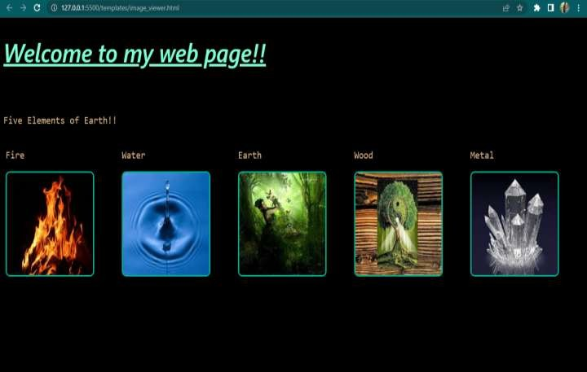

**Question – 2:**

1. Design a chatbot using IBM Watson assistant for hospital. Ex: User comes with query to know the branches for that hospital in your city. Submit the web URL of that chat bot as a assignment.
2. Create Watson assistant service with 10 steps and use 3 conditions in it. Load that script in HTML page.

**Solution:**

**watson_assistant.html**

<!DOCTYPE html>

<html lang="en">

<head>

<meta charset="UTF-8">

<meta http-equiv="X-UA-Compatible" content="IE=edge">

<meta name="viewport" content="width=device-width, initial-scale=1.0">

<title>Watson Assistant</title>

<style>

body{

background-color: black;

background-image: url("https://imageuploadbyrevathi.s3.jp-tok.cloud-object- storage.appdomain.cloud/h3.jpg");

background-repeat: no-repeat; background-size: cover;

}

h1{

color: rgb(255, 0, 0); font-family: forte; font-size: 50px;

}

p{

color: rgb(124, 1, 114);

font-family: Cambria, Cochin, Georgia, Times, 'Times New Roman', serif; font-size: 30px;

font-weight: bolder;

}

</style>

</head>

<body>

<div>

<h1>Patient Registration </h1>

<h1>(OPD, Casualty, Appointment & ORS)</h1>

<p>The patient registration module of the e-Hospital <br> application is used for patient registration <br> in the OPD and Casualty departments as well as <br> to book, confirm and cancel appointments.</p>

</div>

</body>

<script> window.watsonAssistantChatOptions = {

integrationID: "66a20c11-cda3-443b-885f-8ad0ed2c4227", // The ID of this integration. region: "us-south", // The region your integration is hosted in.

serviceInstanceID: "f0e03510-f198-4fa8-a111-86f1a4f21a35", // The ID of your service instance. onLoad: function(instance) { instance.render(); }

};

setTimeout(function(){

const t=document.createElement('script');

t.src="https://web-chat.global.assistant.watson.appdomain.cloud/versions/" + (window.watsonAssistantChatOptions.clientVersion || 'latest') + "/WatsonAssistantChatEntry.js";

document.head.appendChild(t);

});

</script>

</html>

